 | Filing Reference : |  | GG/COMS/TS.2/3
 | Document Title : |  | Use-Case Realization Report (Analysis)  Login
 | Version : |  | 1.0
 | Prepared By : |  | Koh Ming Jin
 | Date Created : |  | Monday, Jul 29th, 2011
Approved By :
 |  | Tran Ba Tien |  | Date
 |  | Project Manager |  | 29th Jul 2011
©2011 [Hoang Kim joint stock Company].
The information contained in this document is the property of [Hoang Kim joint stock Company]. The contents must not be reproduced, wholly or in part, for purposes other than for which it has been supplied, without the prior permission of [Hoang Kim joint stock Company], or, if it has been furnished under contract to another party, as expressly authorised under that contract. [Hoang Kim joint stock Company] shall not be liable for any errors or omissions.

Revision History
Date | Version | Description | Author
29/Jul/2011 | 1.0 | Initial Document | Koh Ming Jin

Table of Contents
1. Brief Description 4
2. Flow of Events 4
2.1 Standard Flow 4
2.2 Exception 4
3. Interaction Diagrams 4
3.1 Collaboration Diagram for System Login 4
4. Participating Objects 5
4.1 Main Page 5
4.2 Login Page 5
4.3 Main Controller 5
4.4 Security Controller 5
4.5 Role 5
4.6 Employee 5
5. Class Diagrams 5
5.1 Domain Class Diagram: View Login 5
6. Derived Requirements 6

Use-Case Realization Report
View Login

Brief Description
This use case enables an employee to log in into the system.

Flow of Events
The standard flow of events for this use case and any exceptions are described in the following subsections. See section 3.1 for an overview of the participating Actors and Domain Objects.

Standard Flow
The flow of events is described as follows:

- The use case starts when a staff selects the Login option of the Login Page.
- This will redirect the employee to the Login Page.
- The Login Page, which includes the employee ID and password fields, will be displayed.
- The employee will input the required information and press login (i.e. operation login).
- The MainController will call the login operation of SecurityController.
- The SecurityController will retrieve the ID and password using operation retrieveIDPw (Employee object ) and verify the input information with the retrieved data.
- If the employee ID and password matches, the SecurityController will return a status (operation returnStatus) and return the role for the authenticated user.
- Subsequently, the SecuirtyController will display the new content on the MainPage (operation show) based on the role of the user.
- The use case terminates.

Exception
- Authentication fails. If the employee’s input information do not match with the existing credentials, an error message will be displayed and the employee will be redirected to the login page again.

Interaction Diagrams

Collaboration Diagram for System Login

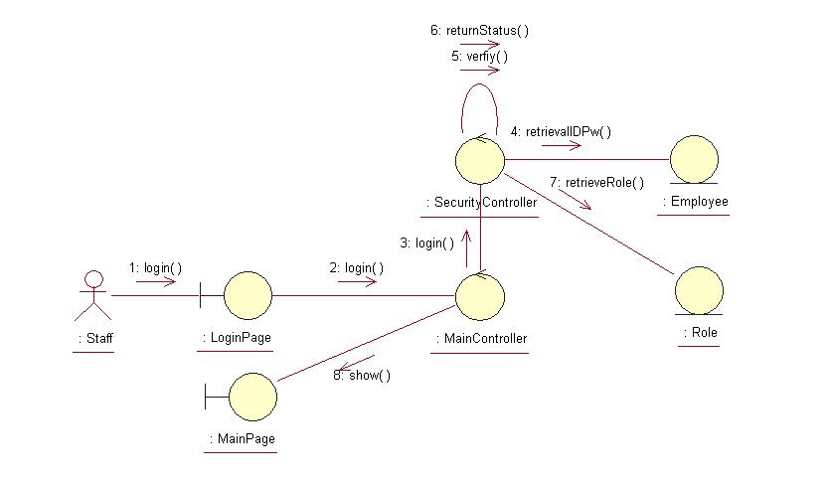
The above collaboration diagram shows the main process flow of this use case.

Participating Objects

Main Page
This object renders the contents after the actor has login. The Director, Department Manager and Operation Manager actors use this object.

Login Page
This object renders the contents to allow actors to login into the system. All actors use this object.

Main Controller
This object acts as the middleman between Main Page and the Error Controller. It will translate interactions with the view into actions to be performed by the Error Controller.

Security Controller
This object acts as the middleman between Main Pages and the Employee and Role objects. It will translate interactions with the view into actions to be performed by the Employee and Role objects.

Role
This object stores the details concerning the Role of the COMS.

Employee
This object stores the details concerning the Employee of the COMS.

Class Diagrams

Domain Class Diagram: View Login

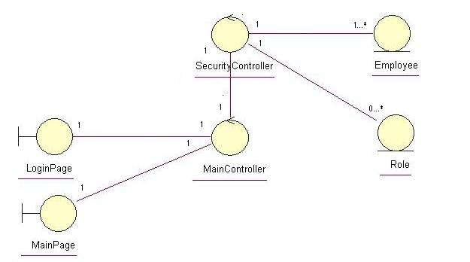

Derived Requirements
The Employee barcode scanner or PC keyboard and mouse will be used to login into the system (if any) and view all the system responses.

